Cricket Data Visualization and Analysis using Power BI
Master of Technology
in
Artificial Intelligence

by

Rakesh Kumar Giri (24AI06011)
Harsh Raj (24AI06014)
Rahul Brijpuriya (24AI06016)

Under the guidance of

Dr. Padmalochan Bera

Department of Computer Science and Engineering
School of Electrical and Computer Sciences
IIT Bhubaneswar

ACKNOWLEDGEMENT

We express our sincere gratitude to our project guide Dr. Padmalochan Bera sir of Computer science and Engineering for giving me an opportunity to accomplish the project. With his active support and guidance, this project report has been successfully completed.

Rakesh Kumar Giri 24AI06011
Harsh Raj 24AI06014
Rahul Brijpuriya 24AI06016

Table of Contents

Sl. No. | Title | Page no.
I | Abstract | 6
II | Introduction | 7
III | Basic description of work | 10
IV | Technologies used | 12
V | Methodology | 13
V.I | Data Collection | 13
V.II | Data Cleaning and Transformation in Pandas | 14
V.III | Data Transformation in Power Query | 15
V.IV | Data Modelling and building parameters using DAX | 17
V.V | Building Dashboards using Power BI | 21
VI | Future Scope | 31

Table of Figures

Fig no. | Title
1 | Project Methodology Diagram
2 | Dataset Load in Power Query Editor
3 | Data Cleaning and Transformation
4 | Data Cleaning and Transformation
5 | Conditional Column
6 | Transformation Steps
7 | ER Diagram
8 | DAX Features
9 | DAX Formula in custom columns
10 | ER Diagram after measures
11 | Player Analysis Layout
12 | Power Hitter Opener Dashboard
13 | Anchor Dashboard
14 | Finisher Dashboard
15 | All Rounder Dashboard
16 | Bowler Dashboard
17 | Performance Dashboard
18 | Final 11 Dashboard Layout
19(1-4) | Final 11 Selection Criteria
20 | Final 11 Dashboard

I. Abstract
In today’s date data analysis is need for every data analytics to examine the sets of data to extract the useful information from it and to draw conclusion according to the information.

Data analytics techniques and algorithms are more used by the commercial industries which enables them to take precise business decisions. It is also used by the analysts and the experts to authenticate or negate experimental layouts, assumptions, and conclusions. In recent years the analytics is being used in the field of sports to predict and draw various
insights.

Due to the involvement of money, team spirit, city loyalty and a massive fan following, the outcome of matches is very important for all stake holders. In this paper, the last year’s data of Cricket World Cup containing
the player’s details, match venue details, teams, ball to ball details, is taken
and analyzed to make a playing 11 which can beat any cricketing team on any day based on their performances in that world cup.

II. Introduction
As the data available to companies continues to grow both in amount and complexity, so too does the need for an effective and efficient process by which to harness the value of that data. The data analysis process typically moves through several iterative phases.

Data analysis is a process of inspecting, cleansing, transforming, and modeling data with the goal of discovering useful information, informing conclusions, and supporting decision-making. Data analysis has multiple facets and approaches, encompassing diverse techniques under a variety of names, and is used in different business, science, and social science domains. In today's world, data analysis plays a role in making decisions more scientific and helping to operate more effectively.
Cricket is being played in many countries around the world. There are a lot of domestic and international cricket tournaments being held in many countries. The cricket game has various forms such as Test Matches, Twenty20 Internationals, Internationals one day, etc. World Cup is one of the most important tournaments in cricket.

In cricket world cup, 12 different countries play against each other for World Cup trophy. The stakeholders are much more benefited due to the huge popularity and the huge presence of people at the venue. The accuracy of a data depends on the size of the data we take for analyzing and the records that are taken for predicting the outcome.
Cricket is a game played between two teams comprising of 11 players in each team. The result is either a win, lose or a tie. However, sometimes due to bad weather conditions the game is also washed out as

Cricket is a game which cannot be played in rain. Moreover, this game is also extremely unpredictable because at every stage of the
game the momentum shifts to one of the teams between the two. A lot of times the result gets decided on the last ball of the match where the
game gets really close. Considering all these unpredictable scenarios of this unpredictable game, there is a huge interest among the spectators to do some prediction either at the start of the game or during the game. Many spectators also play betting games to win money.
The report discusses a methodology that I followed for the best playing 11 from that world cup considering below factors.

Factors:
Cricket winning can be predicted like all other games. We need to find the best attributes or factors that influences the match outcome. The result of a cricket match depends upon more of in-game and more of pre-game attributes.
Pre-game attributes like pitch, Team strength, weather, venue etc. and in-game attributes like run rate, total run, strike rate, wickets in hand etc. influences a match result predominantly.
Below are the attributes that decides outcome of the cricket match
- Pitch: Unlike other sports, cricket stadiums shape and size is not fixed except the dimensions of the inner circle and pitch which are 30 yards and 22 yards respectively. Outfield variations and pitch can have a substantiate effect on bowling and batting. The spin of the ball, seam movement and the bounce depend upon the nature of the pitch.
It depends on the how the wet is the pitch. The more wet the pitch, the slower it will play. On the off chance that it is drying out, those balls will change significantly, yet all it will get less difficult those drier it gets. Green pitches tend to get easier to bat on.
- Toss: According to cricket analysts, there is sure measure of advantage for a team if it wins the toss. This might not be deciding factor in a match but it would give the team the opportunity of choosing “what they want”.
- Team Strength: The team strength should be balanced for winning a match. Captainship in a team is also a deciding factor. Past records: The past team performances can be considered to predict the outcomes of match. History of games at those venues how did the team performs, performances at that specific venue, performance against the specific opposition and experience at the specific venue.
- Home Ground Advantage: This is another attribute which determines the winner in the match. If you are playing in the home ground condition everything would be in your hands like climatic factor, pitch nature and major role is played by the home crowd. Home team gets better motivation.
- Ground Dimension: This is one of attribute that determines which team will have more advantage considering player’s profiles.

III. Basic description of the work
Cricket is a popular sport with a rich history that has captured the attention of millions of people worldwide. With the growing availability of data and advancements in data analytics techniques, there has been a growing interest in analyzing cricket data to gain insights into player and team performance.
Cricket data analysis projects aim to leverage data from various sources, including match statistics, player profiles, and team records, to identify patterns and trends that can be used to gain insights into the sport. These insights can be used by coaches, analysts, and fans to make informed decisions about player selection, game strategies, and team management.
Furthermore, cricket analysis projects can help in predicting match outcomes, analyzing individual player performance, and identifying key factors that contribute to team success. The insights gained from cricket analysis projects can be used to improve team performance, enhance fan engagement, and drive revenue growth for cricket organizations.
Overall, cricket analysis projects are a valuable tool for gaining insights into the sport and have the potential to make a significant impact on the game of cricket.
The analysis of cricket data can provide valuable insights into player and team performance, match trends, and other key metrics. However, the volume and complexity of cricket data can make it challenging to identify patterns and trends.
The work is to perform data analysis on cricket data to gain insights into player and team performance, identify key trends and patterns, and present the results in an easy-to-understand format.

It is basically used for the analysis that which playing 11 has higher chances of winning match.
- It can be used in predicting the teams on the application like DREAM 11 where people choose their teams and compete with each other to win the prizes. It will help the person to form the team of such players that are compatible with the playing conditions.
- It can be used to predict the overall winning chances of team in a particular match on particular ground.\
- It can be used by team management to analyze and made such team that they can give higher percentage of winning.

Definition of terms:
- Batting Average: It is the average number of runs scored per dismissal by a batsman in a cricket match.
- Bowling Average: It is the average number of runs conceded per wicket taken by a bowler in a cricket match.
- Strike Rate: It is the number of runs scored per 100 balls faced by a batsman in a cricket match.
- Run Rate: It is the average number of runs scored per over by a team in a cricket match.
- Toss: It is a coin toss before the start of a cricket match that determines which team will bat or bowl first.
- Venue: It is the location where a cricket match is played.
- Format: It refers to the type of cricket match, such as Test cricket, One Day International (ODI), or T20.
- Innings: It is a term used to describe a team's turn at bat in a cricket match.
- Wicket: It is a term used to describe the act of a bowler getting a batsman out in a cricket match.
- Boundary: It refers to the act of hitting the ball over the boundary line, resulting in four or six runs for the batting team.
- Duck: It refers to the act of getting out without scoring any runs in a cricket match.
- Extras: It refers to the runs scored by a team without the contribution of any batsman, such as wides, no-balls, and byes.

IV. Technologies used
Operating system: Windows 11
IDE: Jupyter Notebook
Analysis Tool: Power BI
Programming Language: Python (Pandas), JavaScript
Dataset: To be scraped from espncricinfo.com

V. Methodology
We have followed the following methodology in the course of my project. The methodology consists of 5 different phases as shown in figure.
- Data Collection
- Data Cleaning and Transformation in Pandas
- Data Transformation in Power Query
- Data Modelling and building parameters using DAX
- Building Dashboards using POWER BI
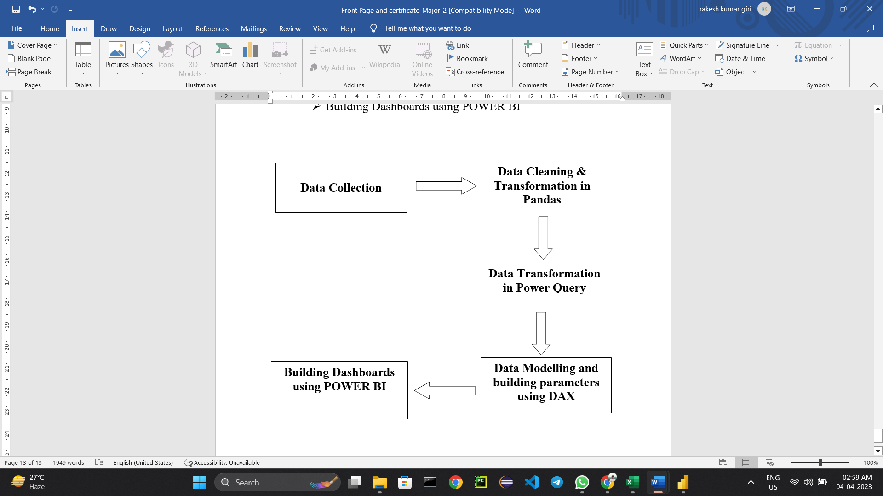
Fig. 1

V.I Data Collection
The data was collected from the https://espncricinfo.com website. The website has data about all matches of Cricket World Cup 2022 T20 format of tournaments. It means that each team bats or bowls for maximum 20 overs each.
We have utilized brightdata.com website to scrap data from espncricinfo portal using Java Script code.

V.II Data Cleaning and Transformation in Pandas
The data obtained from the portal is in json format .So, we have converted these json data to dataframe using pandas.
After conversion some data cleaning techniques like handling null/missing values, handling special characters, removing unwanted columns etc. were performed on the same.
Data transformation involves converting the data into a format that is more suitable(csv) for the data analysis task. This includes converting all json data to csv format.
We have four different datasets named as match_summary.csv, batting_summary.csv, bowling_sumary.csv, players.csv on which further operations will be performed.
The data set obtained after handling the missing values had to be filtered with the help of the attribute selection algorithm. Since, there were multiple attributes it was necessary to identify all important attributes which would be useful for the data analysis tasks.
So, at the end of this transformation process we get a set of attributes using which we get the highest accuracy of prediction for the classification algorithms.
After the attribute selection phase, the list of attributes gets minimized to 7 i.e. team1, team2, winner, margin, ground, machDate, match_id.

V.III Data Transformation in Power Query
Power Query is a data transformation and analysis tool that is part of the Microsoft Power BI and Excel software. It allows users to connect to various data sources, such as databases, spreadsheets, and web pages, and then transform, clean, and reshape the data to meet their specific needs.
Power Query provides a user-friendly interface for performing a range of data preparation tasks, such as filtering, sorting, grouping, and merging data. It also offers a wide range of data transformation options, such as splitting columns, pivoting data, and creating custom calculations.
One of the key benefits of Power Query is that it enables users to perform complex data transformations without the need for coding or complex formulas. It also allows users to easily repeat and automate these data preparation tasks, saving time and reducing the risk of errors.
Overall, Power Query is a powerful tool for anyone working with data in Microsoft Power BI or Excel, and it can help users to streamline their data preparation workflows and gain valuable insights from their data.
We have used Power Query to transform data according to our need. We have used different techniques for data cleaning and transformation like removing extra characters using delimiters, renaming the column names, splitting columns, adding conditional columns etc.

Step 1: Load csv datasets to Power Query Editor

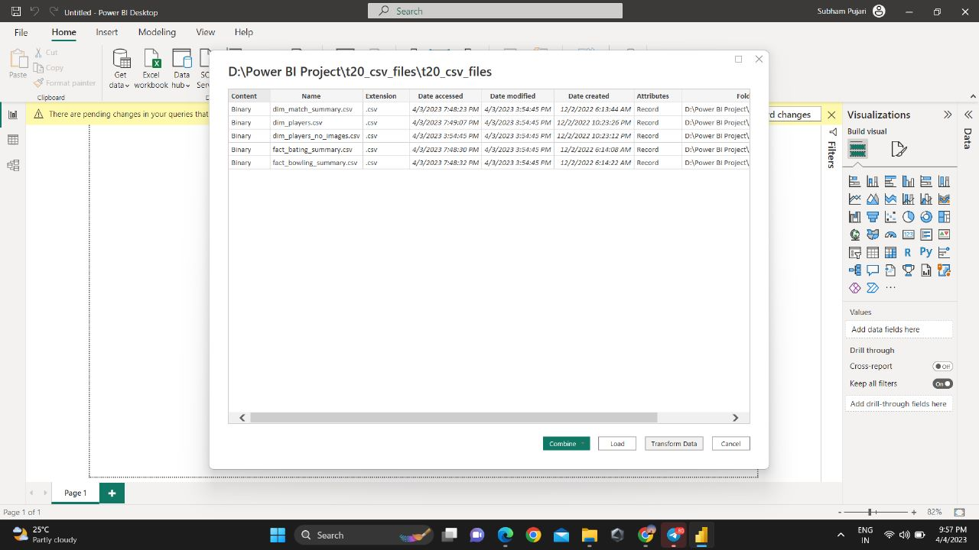
Fig. 2

Step 2: Making first row as column headers, removing the unwanted columns and renaming the required columns.

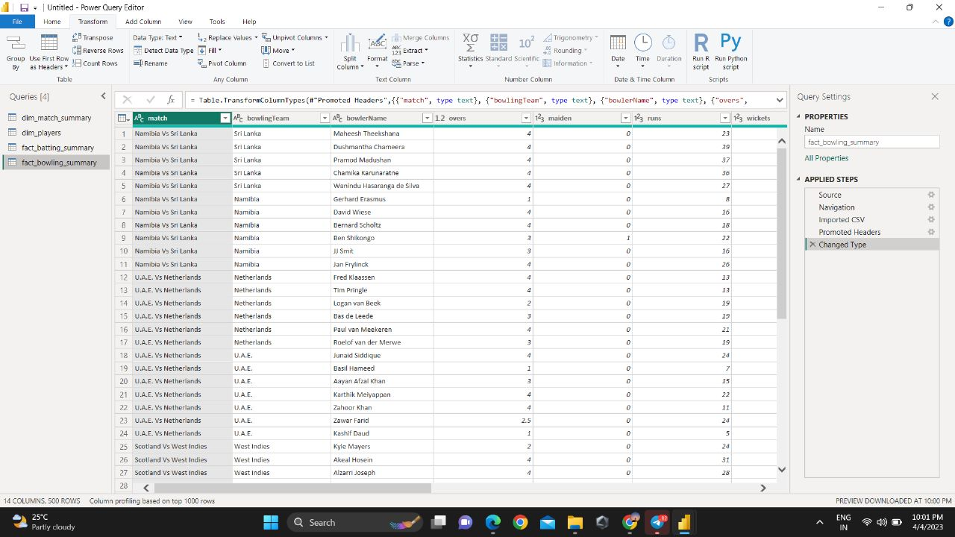
Fig. 3

Step 3: Changing data types of multiple columns like 4’s (fours), 6’s (sixes), 0’s (zeros), dismissal (out/ not out) etc.

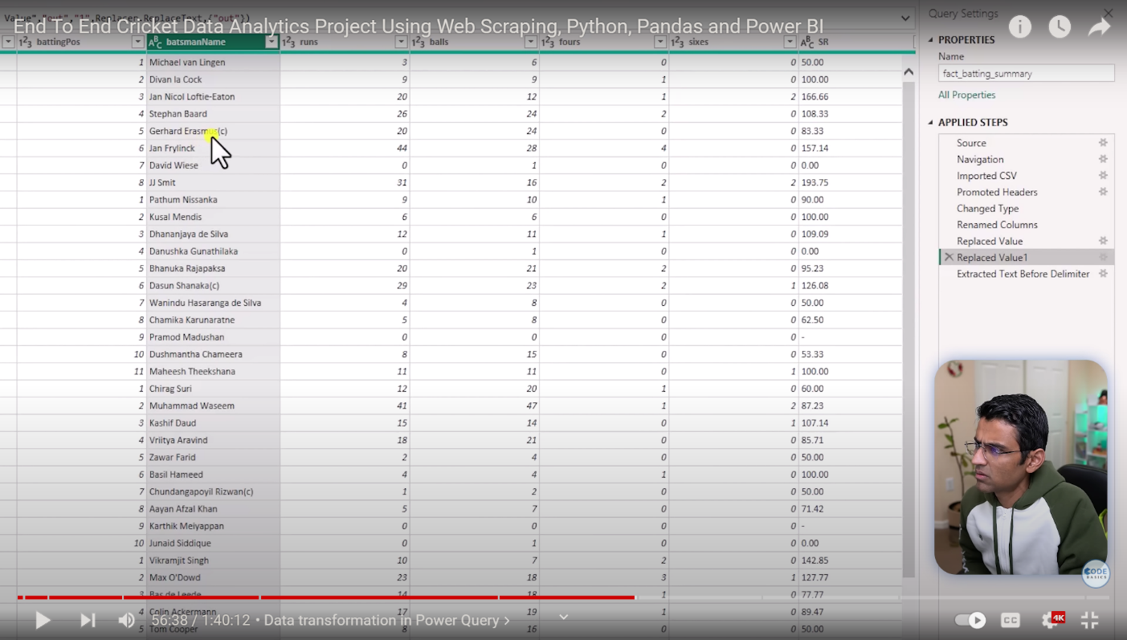
Fig. 4
Step 4: Adding conditional columns using delimiters, where according to the given condition applied on any specific column, we have created a new column.

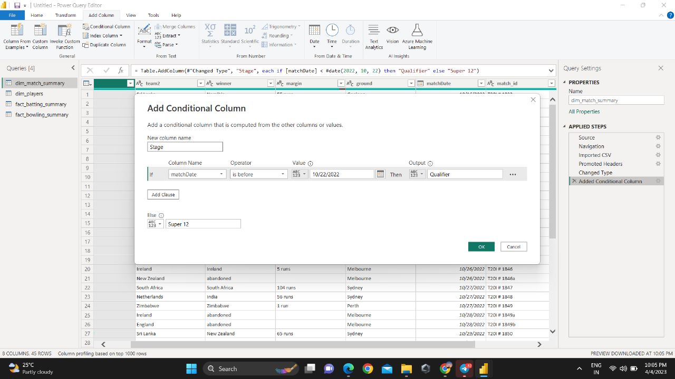
Fig. 5

These are the other transformation steps including splitting, appending, merging, filtering rows, extracting text using delimiters etc.

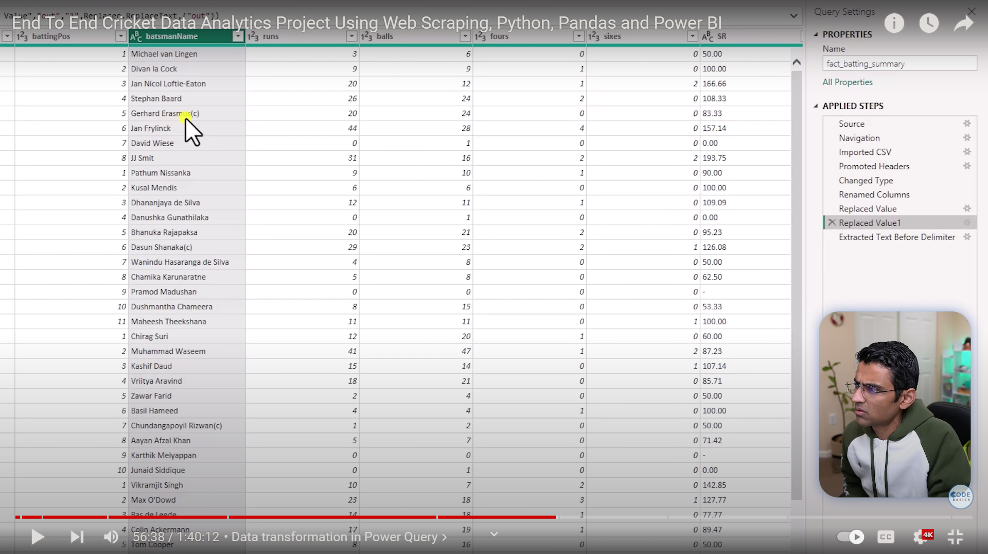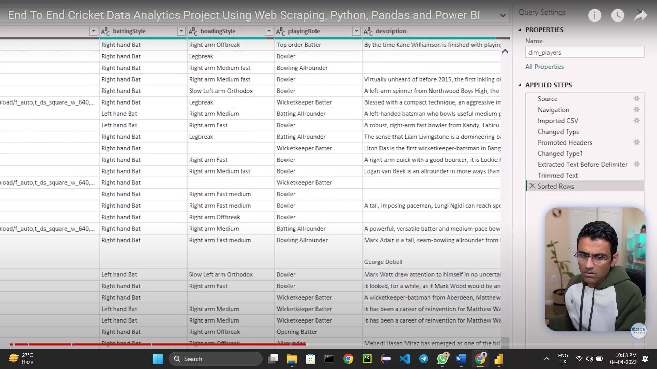
Fig. 6

V.IV Data Modelling and building parameters using DAX
DAX (Data Analysis Expressions) is a formula language used in Microsoft Power BI, Excel, and Analysis Services to create custom calculations and aggregations for data analysis. DAX formulas are used to create new calculated columns, measures, and tables based on existing data sources.
DAX includes a rich set of functions for manipulating data, including functions for filtering, grouping, and summarizing data, as well as mathematical and statistical functions. It also supports advanced calculations such as time intelligence, which allows users to analyze data over time periods, and the ability to create complex relationships between tables.
DAX formulas are written using a syntax that is similar to Excel formulas, making it easy for users familiar with Excel to learn and use. However, DAX is designed to work with large datasets, and it is optimized for performance in complex data analysis scenarios.
Measures calculate a result from an expression formula. When you create your own measures, you’ll use the Data Analysis Expressions (DAX) formula language. DAX includes a library of over 200 functions, operators, and constructs. Its library provides immense flexibility in creating measures to calculate results for just about any data analysis need.
Some common uses of DAX include calculating year-to-date sales, creating rolling averages, and calculating ratios and percentages. DAX formulas use functions and operators to perform calculations, and they can be written using a formula bar in Power BI or Excel.

ER_DIAGRAM:

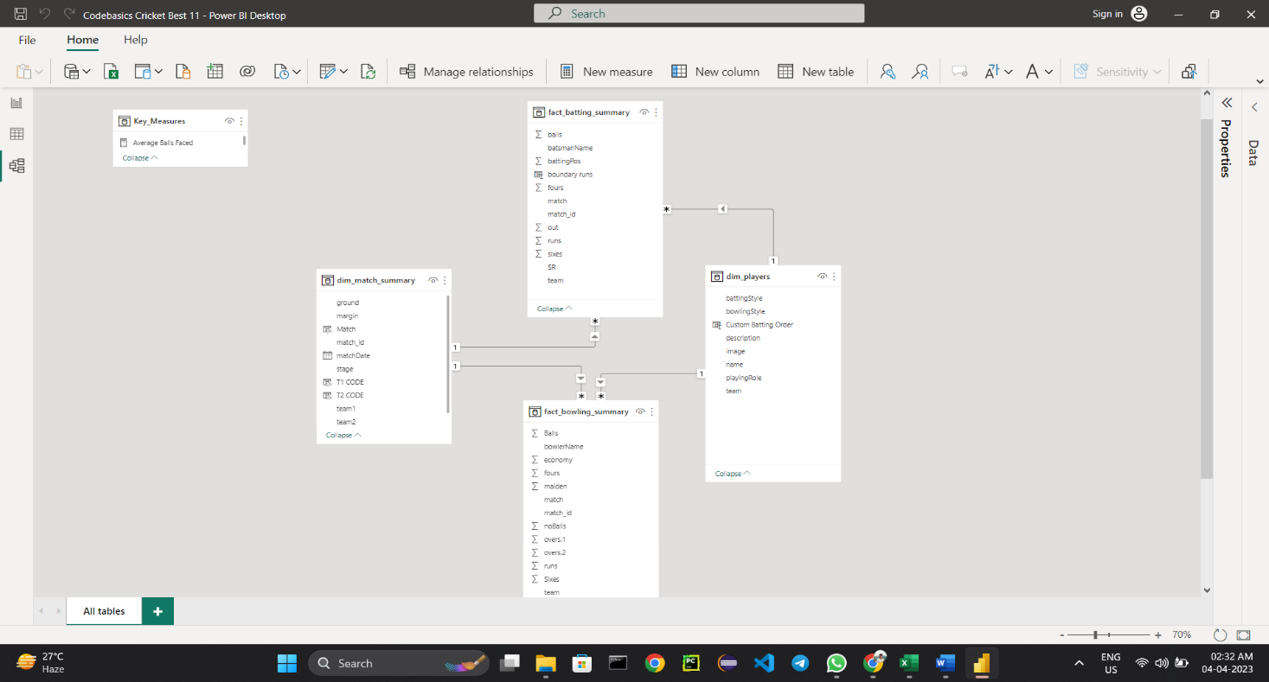
Fig. 7

Now we have created the links between all tables according to the primary key and foreign keys. Once linking done, the DAX formulas will be applied according to the measures on each table. We have used the below mentioned DAX formulas:
SUM: SUM is a DAX function used to calculate the sum of a column or expression in a table or data model.
COUNT: COUNT is a DAX function used to count the number of rows in a table or column that contain a value or meet a specified condition.
DIVIDE: DIVIDE is a DAX function used to perform division in a table or data model, while handling zero and null values
ROUNDUP: ROUNDUP is a DAX function used to round a number up to a specified number of digits.
ISFILTERED: ISFILTERED is a DAX function that checks whether an expression has been filtered or not.

These are the measures we have applied for batting and bowling summary on existing columns.

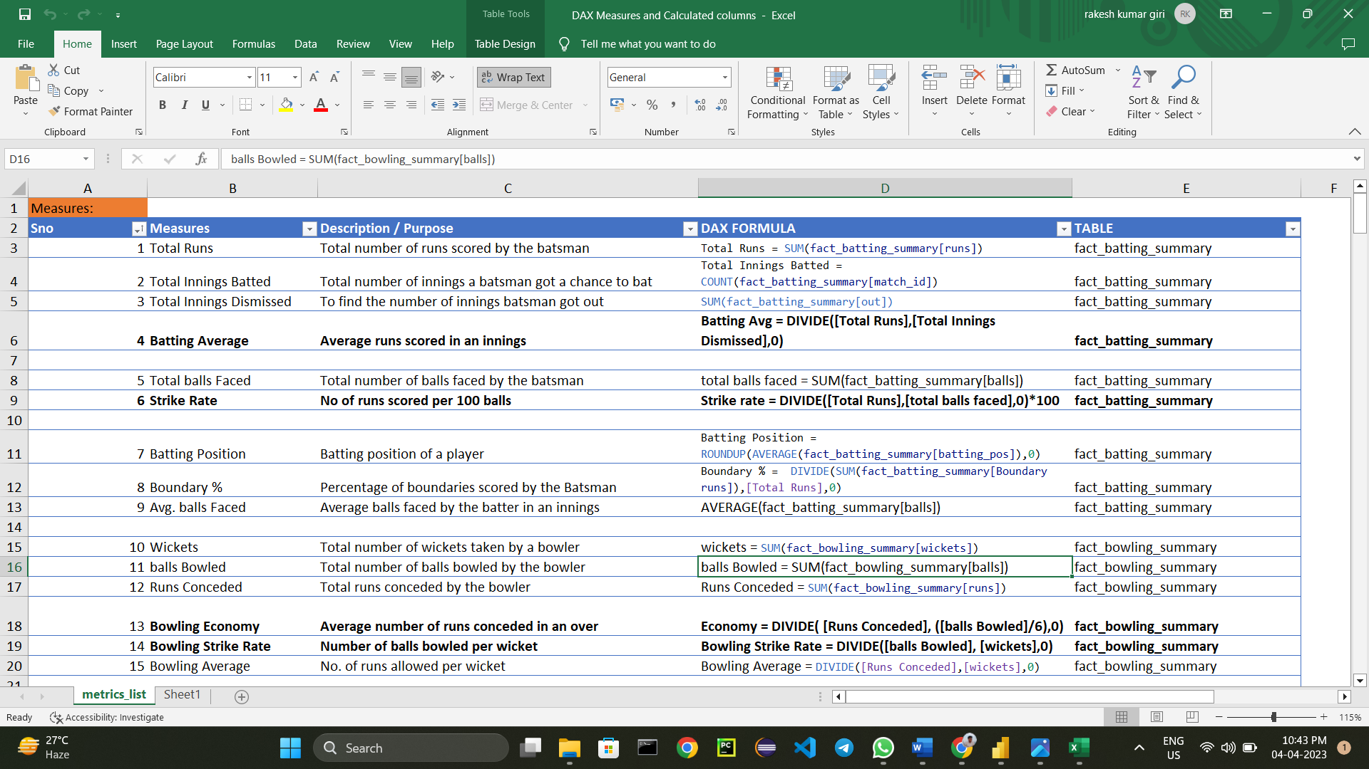

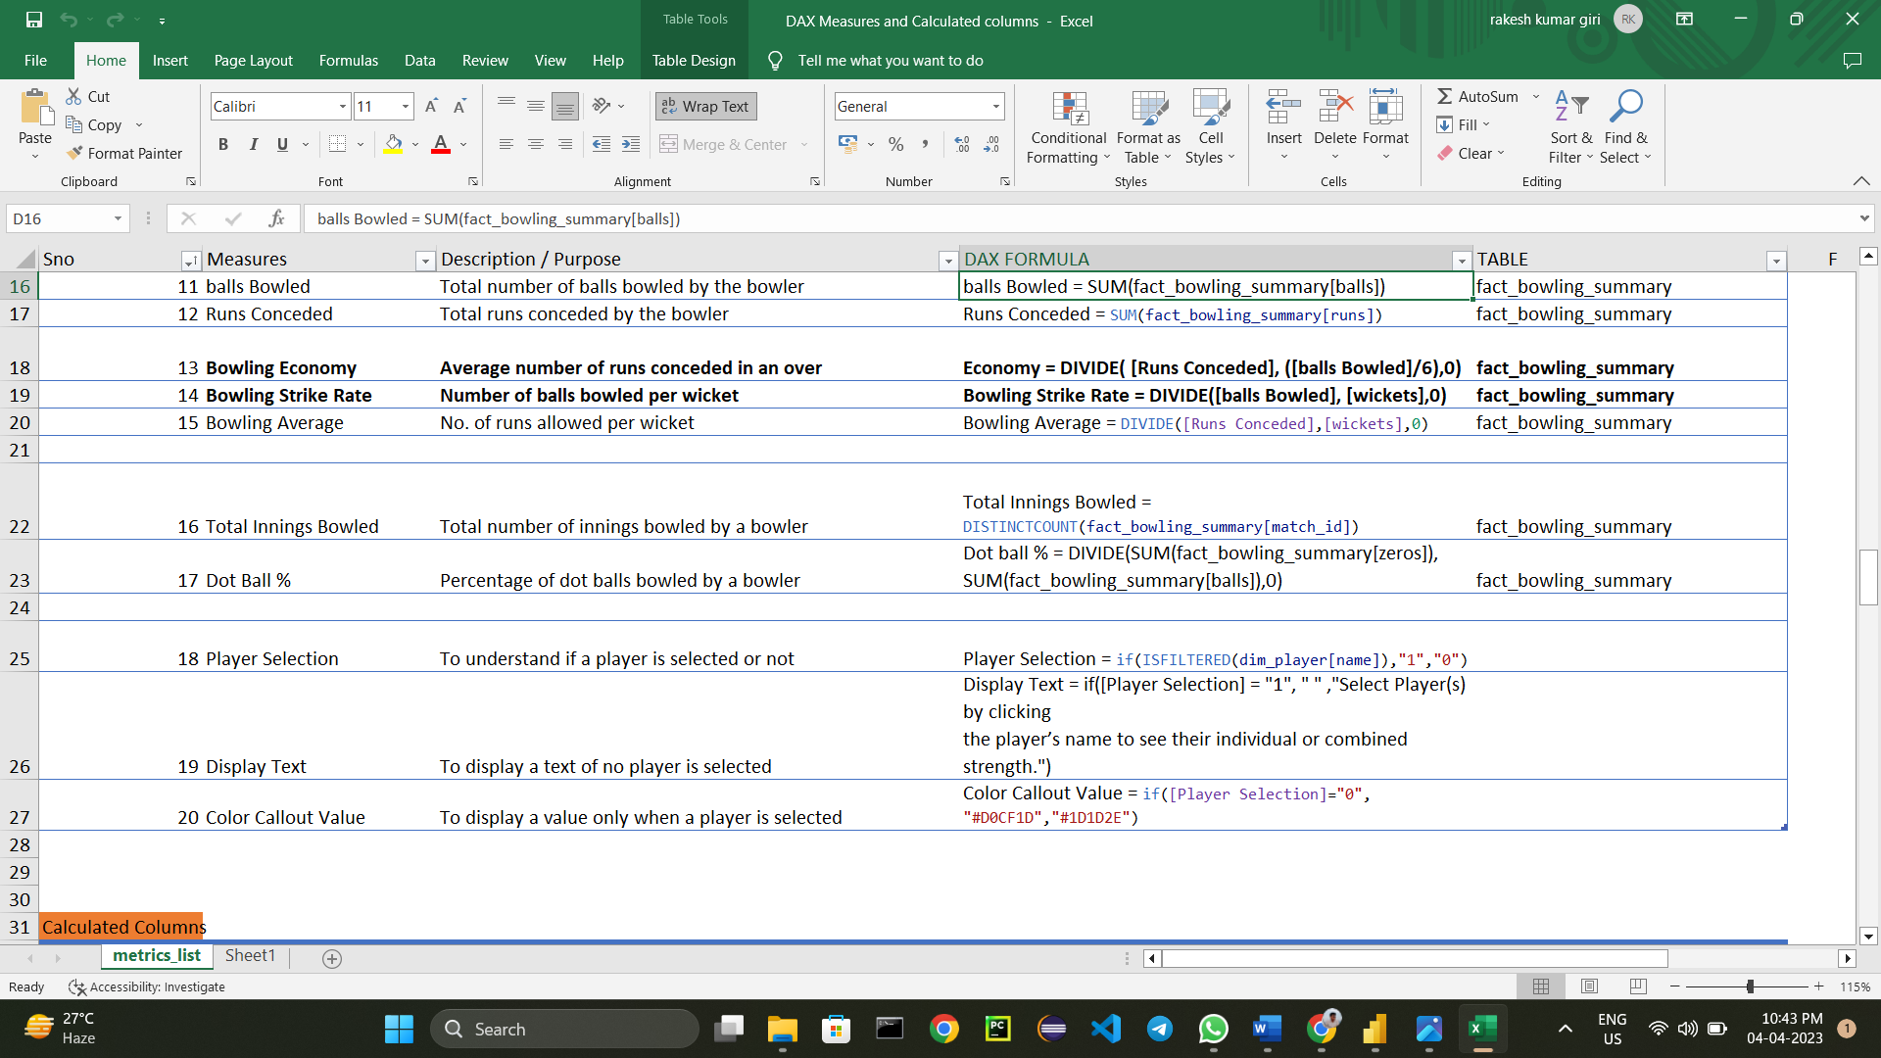
Fig. 8

We have also created some new fields using below DAX formula and measures to find the total number of runs scored by hitting fours and sixes and to find the total number of runs conceded by bowlers in boundaries.

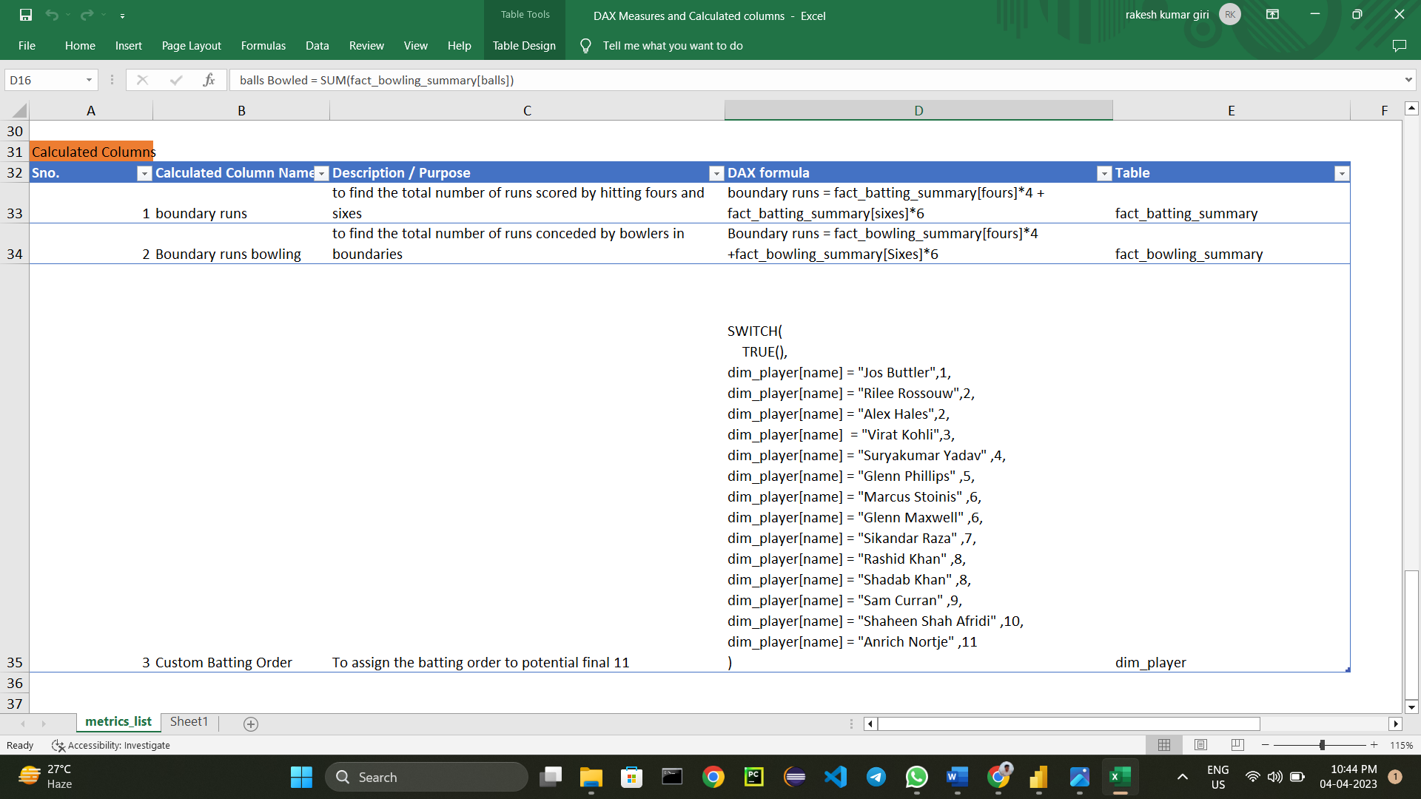
Fig. 9

After applying all the DAX formulas, we will get the final data view on which we will proceed with the Dashboard development.

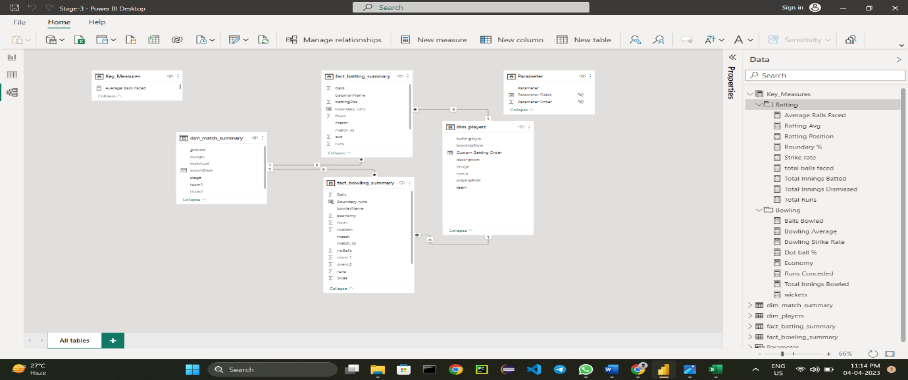
Fig. 10

V.V Building dashboards using Power BI
A dashboard in Power BI is a visual representation of key data and metrics from a data model. It is designed to provide an at-a-glance view of important information and insights, and is typically used to monitor the performance of a business or organization.
Dashboards in Power BI can include a variety of visualizations, such as charts, tables, gauges, and maps. These visualizations can be interactive, allowing users to explore the data and drill down into specific details.
To create a dashboard in Power BI, you first need to create a data model by connecting to your data sources and transforming the data as needed. Once you have a data model, you can start building your dashboard by adding visualizations and arranging them on the canvas.
Power BI also includes a range of tools for customizing and formatting our dashboard, such as themes, colors, and fonts. You can also add filters and slicers to allow users to interact with the data and explore different perspectives.
Overall, a well-designed dashboard in Power BI can provide valuable insights and help users make data-driven decisions in real-time.
We have created player analysis dashboard for power hitters, anchors/middle order, finishers, all-rounder and bowler using the below layout.

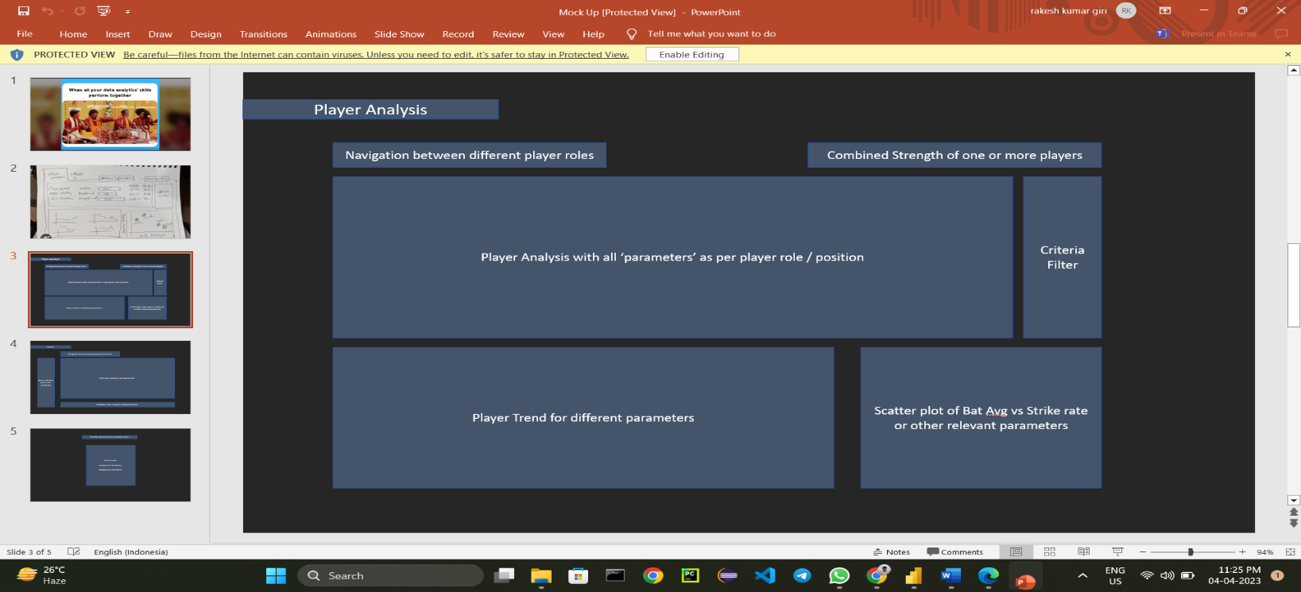
Fig. 11

Power Hitter Opener Dashboard:

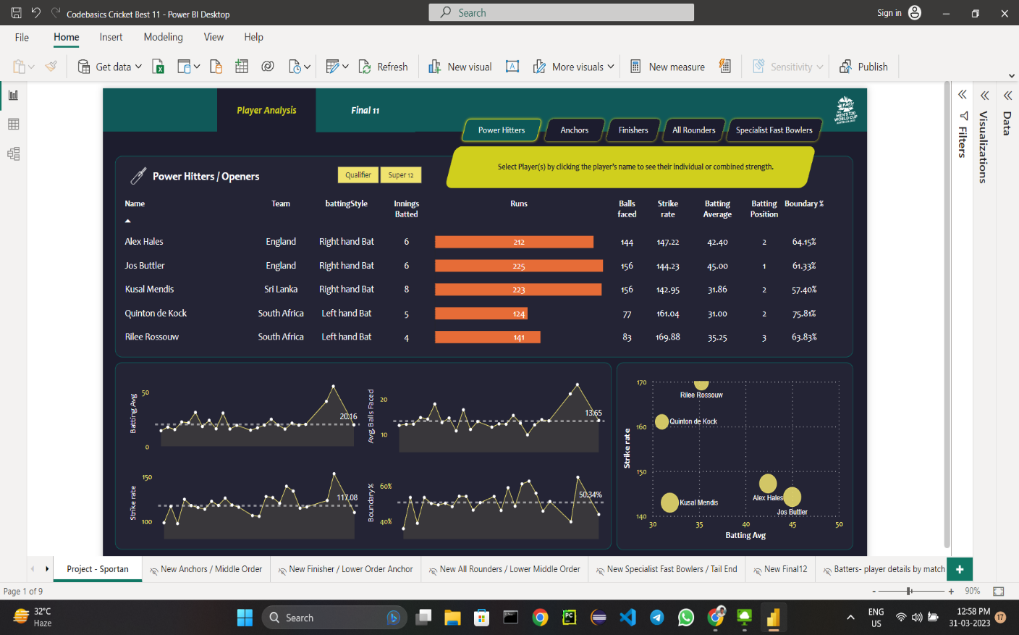
Fig. 12

In this dashboard, we have analyzed all openers data. We have taken the players into consideration who have batting average greater than 30, strike rate greater than 140, minimum 3 innings batted, more than 50% runs scored through boundaries, batting position is max to 3rd.
Table is used for the overview of batsman like name, team, batting style, innings batted, runs scored, balls faced, strike rate, average, batting position, boundary percentage.
Area Chart is used to show the batting average, average balls faced, strike rate and boundary percentage according to the match date.
Scatter plot is used for the batting average according to the strike rate for all the top order players.

Anchor Dashboard:

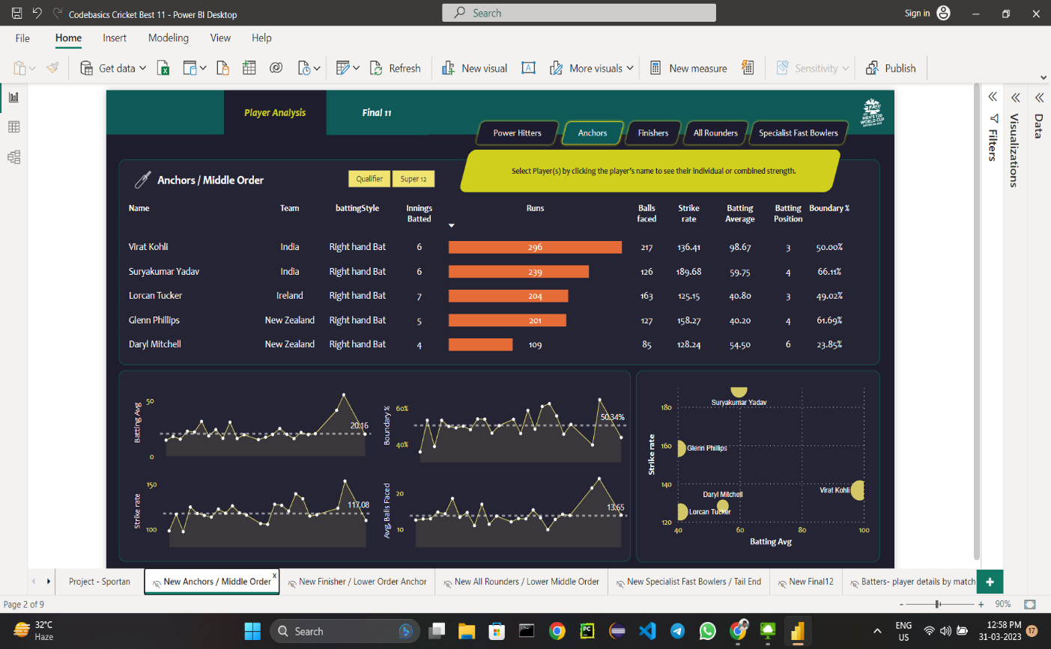
Fig. 13

In this dashboard, we have analyzed all middle order players data who anchors the innings. We have taken the players into consideration who have batting average greater than 40, strike rate greater than 125, minimum 3 innings batted, minimum 20 balls faced, batting position is greater than 2.
Table is used for the overview of batsman like name, team, batting style, innings batted, runs scored, balls faced, strike rate, average, batting position, boundary percentage.
Area Chart is used to show the batting average, average balls faced, strike rate and boundary percentage according to the match date.
Scatter plot is used for the batting average according to the strike rate for all the middle order players.

Finishers Dashboard:

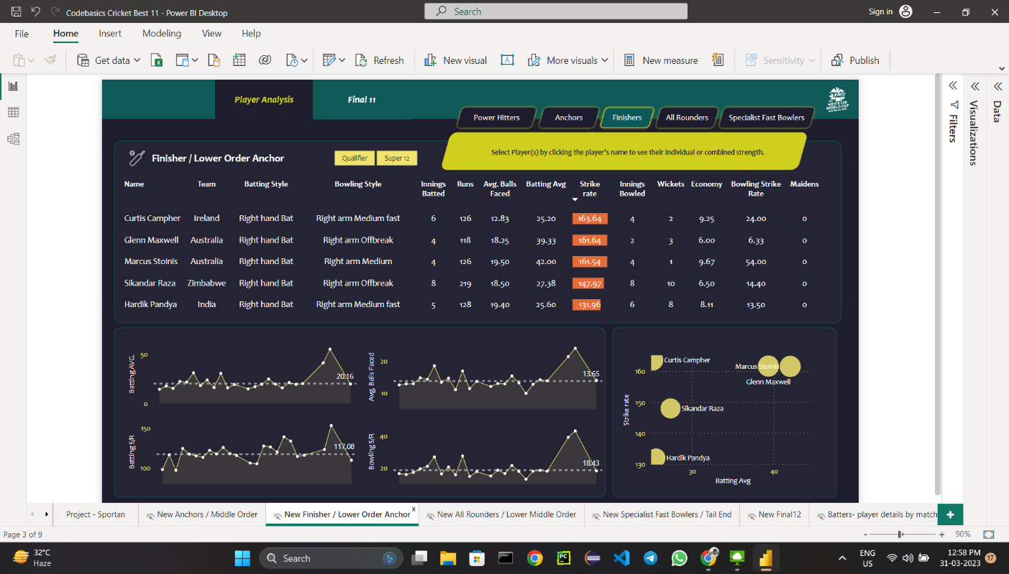
Fig. 14

In this dashboard, we have analyzed all middle order players data who anchors the innings . We have taken the players into consideration who have batting average greater than 20, strike rate greater than 160, minimum 3 innings batted, minimum 15 balls faced, batting position is greater than 4.
Table is used for the overview of batsman like name, team, batting style, innings batted, runs scored, balls faced, strike rate, average, batting position, boundary percentage.
Area Chart is used to show the batting average, average balls faced, strike rate and boundary percentage according to the match date.
Scatter plot is used for the batting average according to the strike rate for all the lower order players.

All Rounders Dashboard:

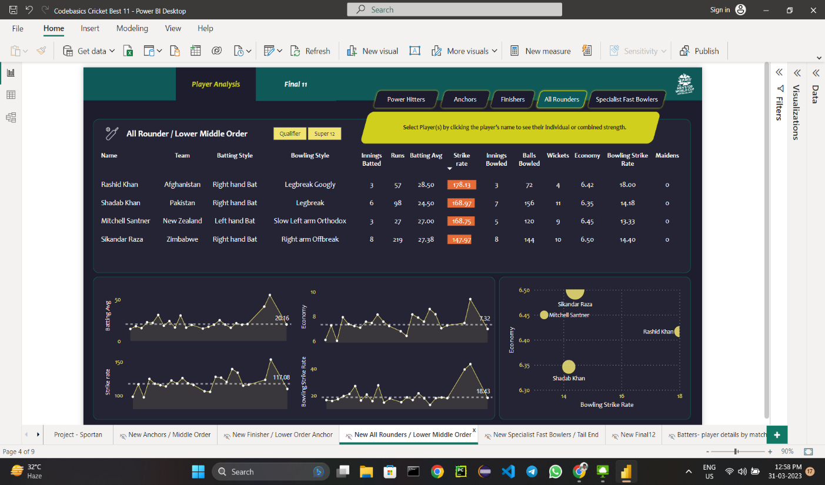
Fig. 15

In this dashboard, we have analyzed all-rounders data. We have taken the players into consideration who have batting average greater than 15, strike rate greater than 140, minimum 2 innings batted, minimum 10 balls faced, batting position is greater than 5, bowling economy is less than 7, bowling strike rate is less than 20 and minimum 2 innings bowled.
Table is used for the overview of batsman like name, team, batting style, innings batted, runs scored, balls faced, strike rate, average, batting position, boundary percentage.
Area Chart is used to show the batting average, bowling economy, strike rate and bowling strike rate according to the match date.
Scatter plot is used for the batting average according to the strike rate for all the all-rounders.

Bowler Dashboard:

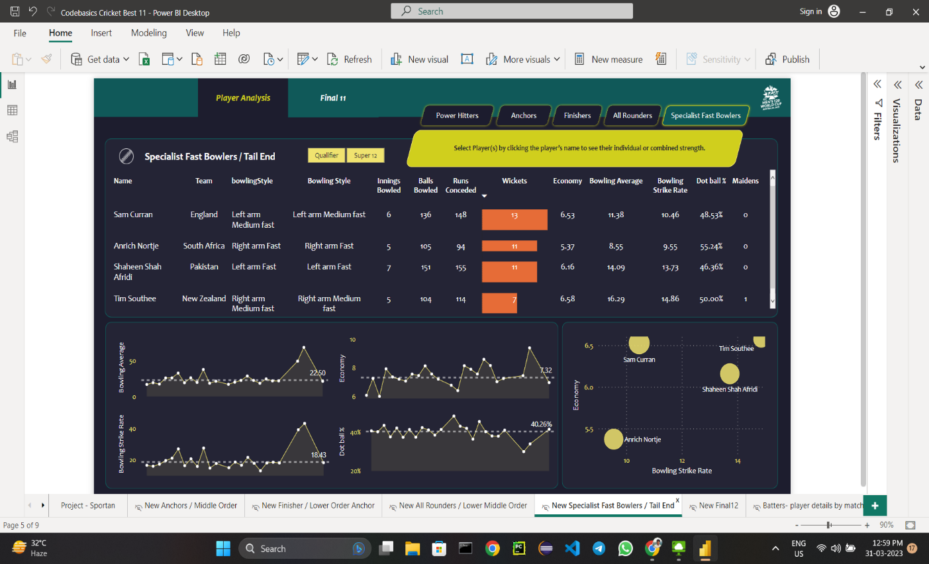
Fig. 16

In this dashboard, we have analyzed all bowler’s data. We have taken the players into consideration who have bowling average less than 20, economy less than 7, minimum 4 innings bowled, bowling strike rate less than 16, dot ball percentage greater than 40.
Table is used for the overview of batsman like name, team, bowling style, innings bowled, balls bowled, runs conceded, wickets taken, maiden overs bowled, bowling average, economy, bowling strike rate, dot ball percentage.
Area Chart is used to show the bowling average, average balls bowled, bowling strike rate and economy according to the match date.
Scatter plot is used for the bowling strike rate average according to the economy for all the bowlers.

Performance Dashboard:
We have created three different dashboards for batting, bowling, all-rounders.

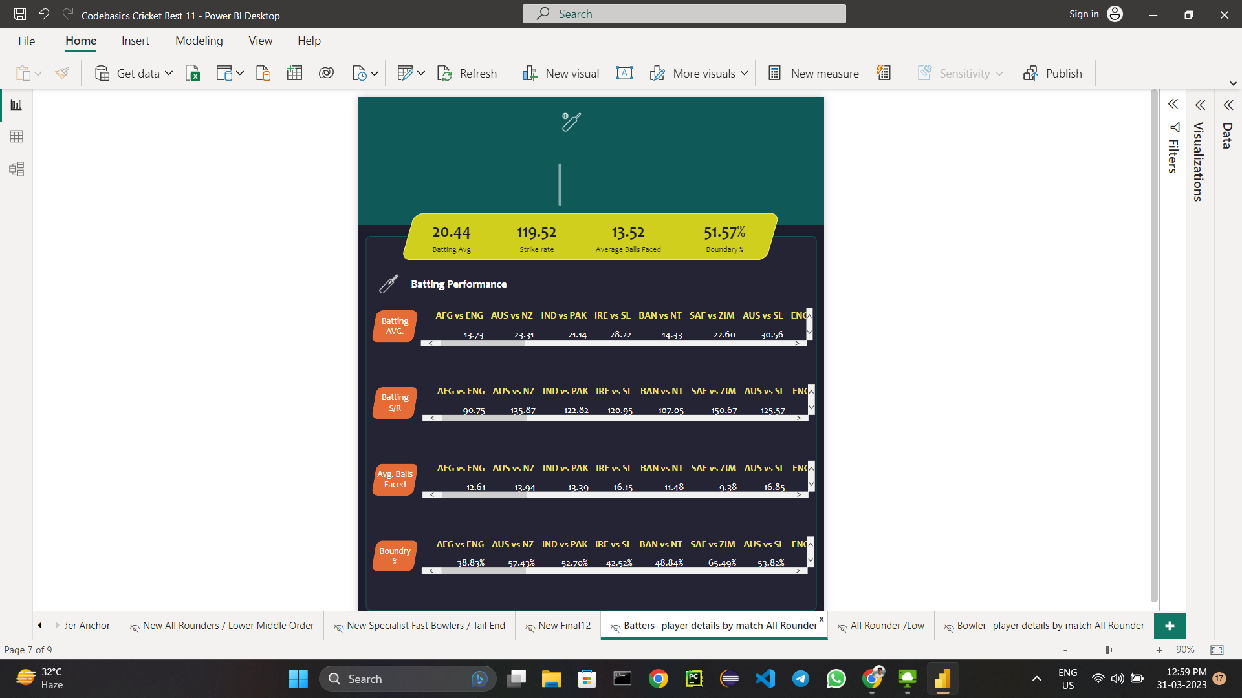
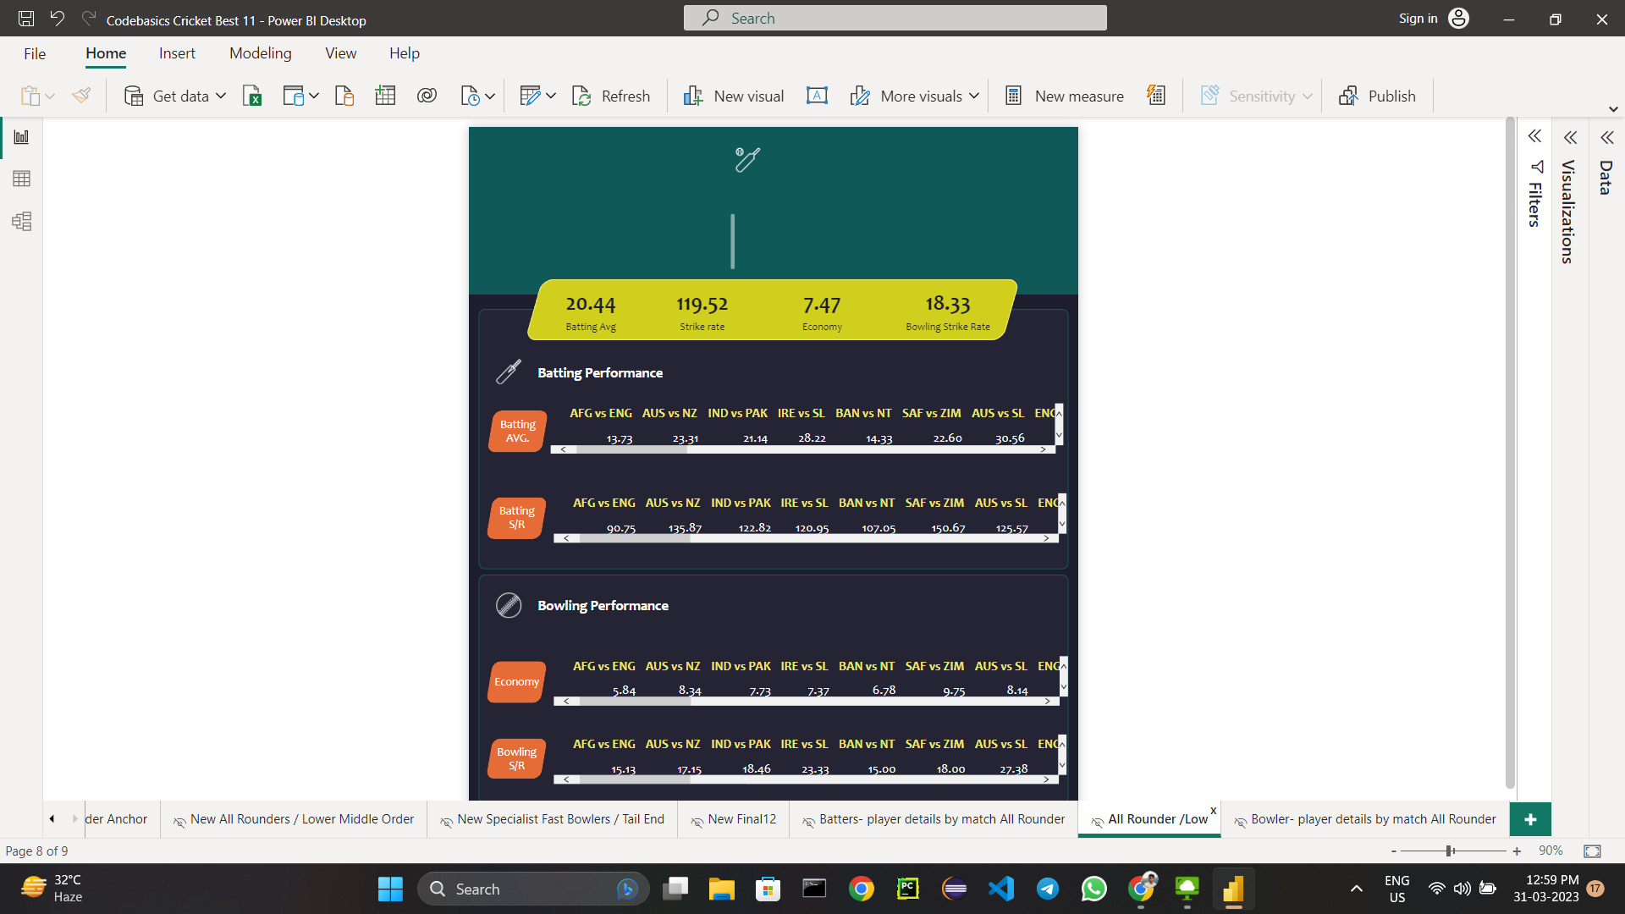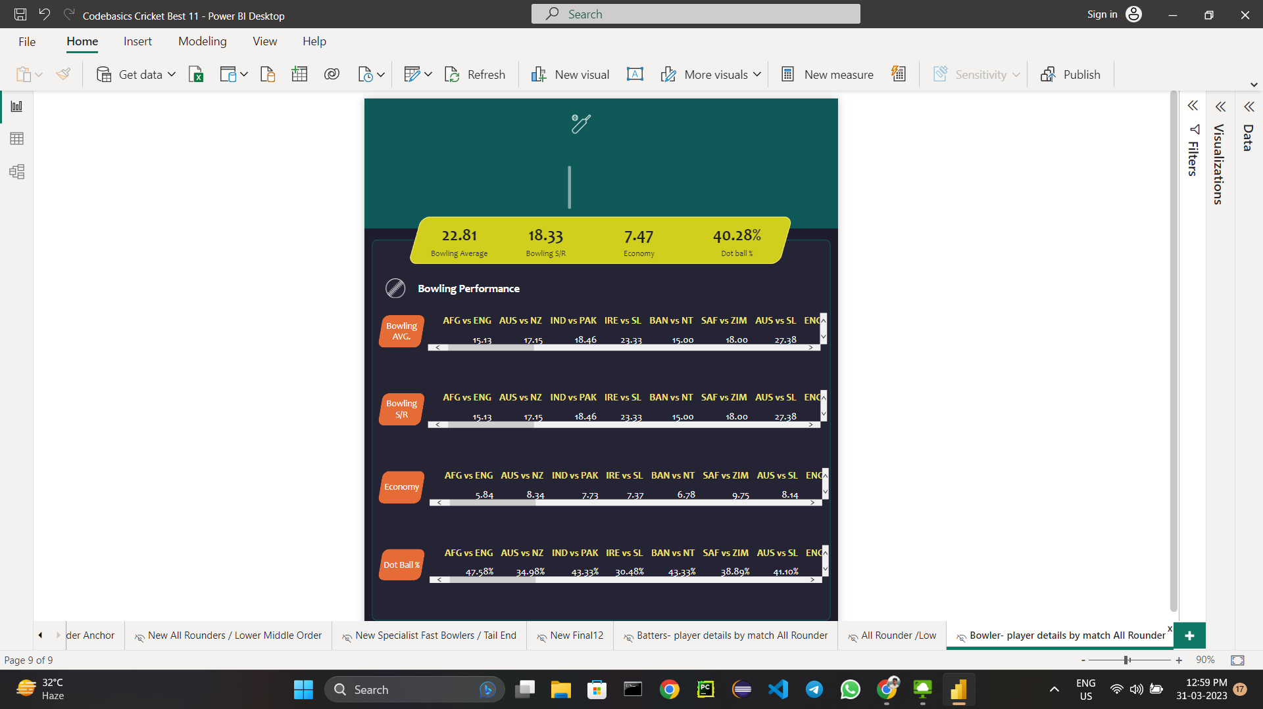

Fig. 17

Final 11 Dashboard:
After creating all these dashboards, we have used some criteria on different parameters to find all the top players across the globe to form a team which is capable to score 180 runs on an average and can defend 150 runs on an average.
We have used the below layout to create a dashboard for the final 11 players.

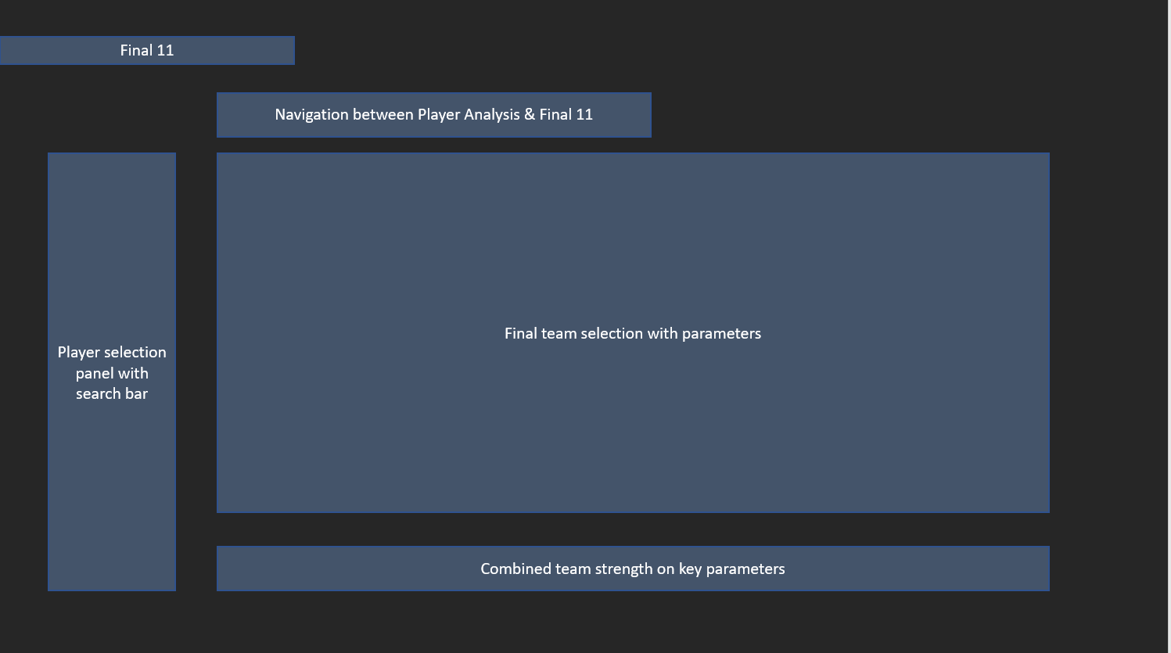

Fig. 18

This dashboard will have combined data for all those 11 players. We also have combined team strength for that team. In player selection panel we are able to change the players according to the statistics. Final team selection with parameters field has all the details of players who are included in the playing 11.
The final team will be based on these four conditions:

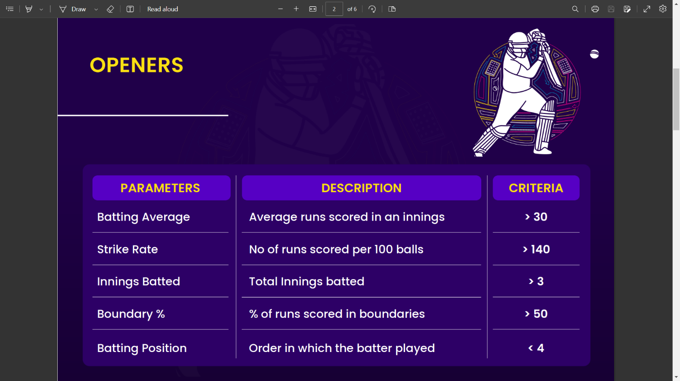

Fig 19.1

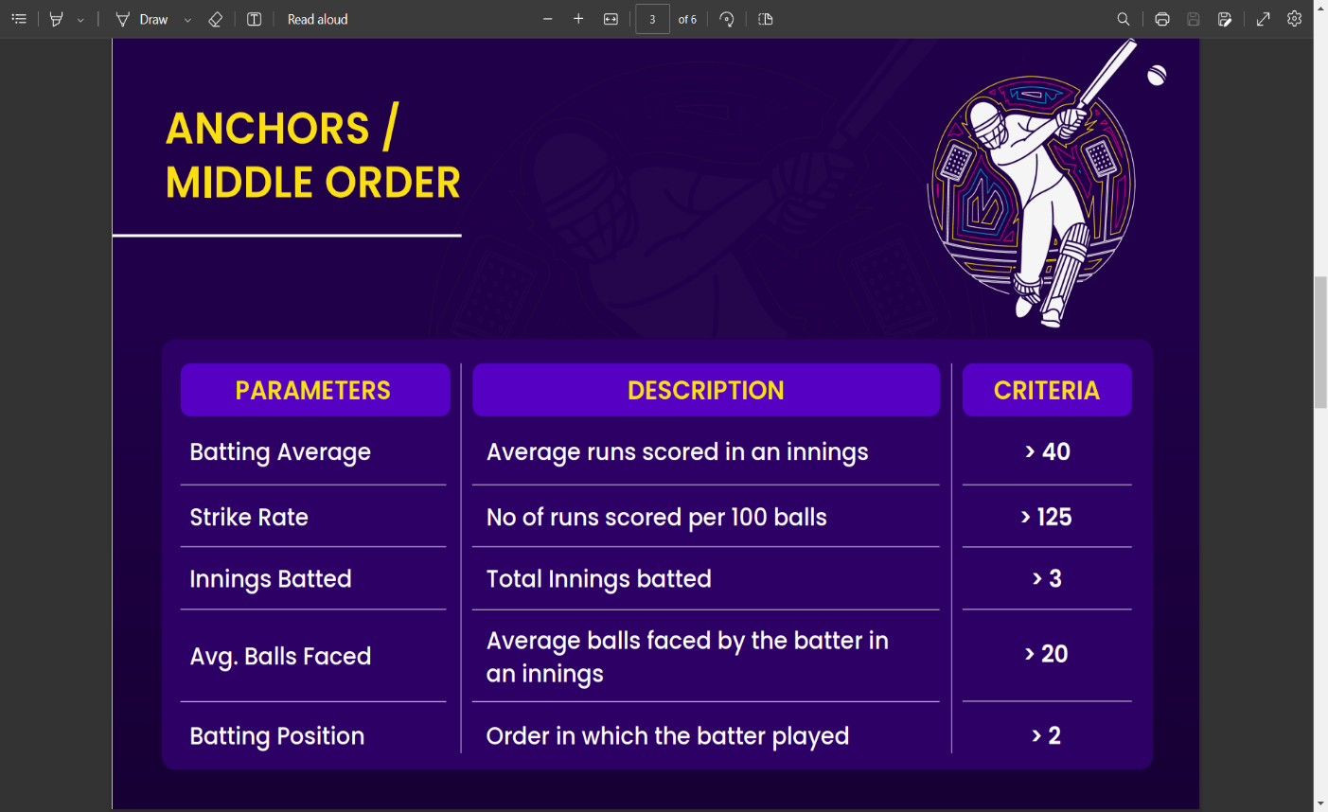

Fig 19.2

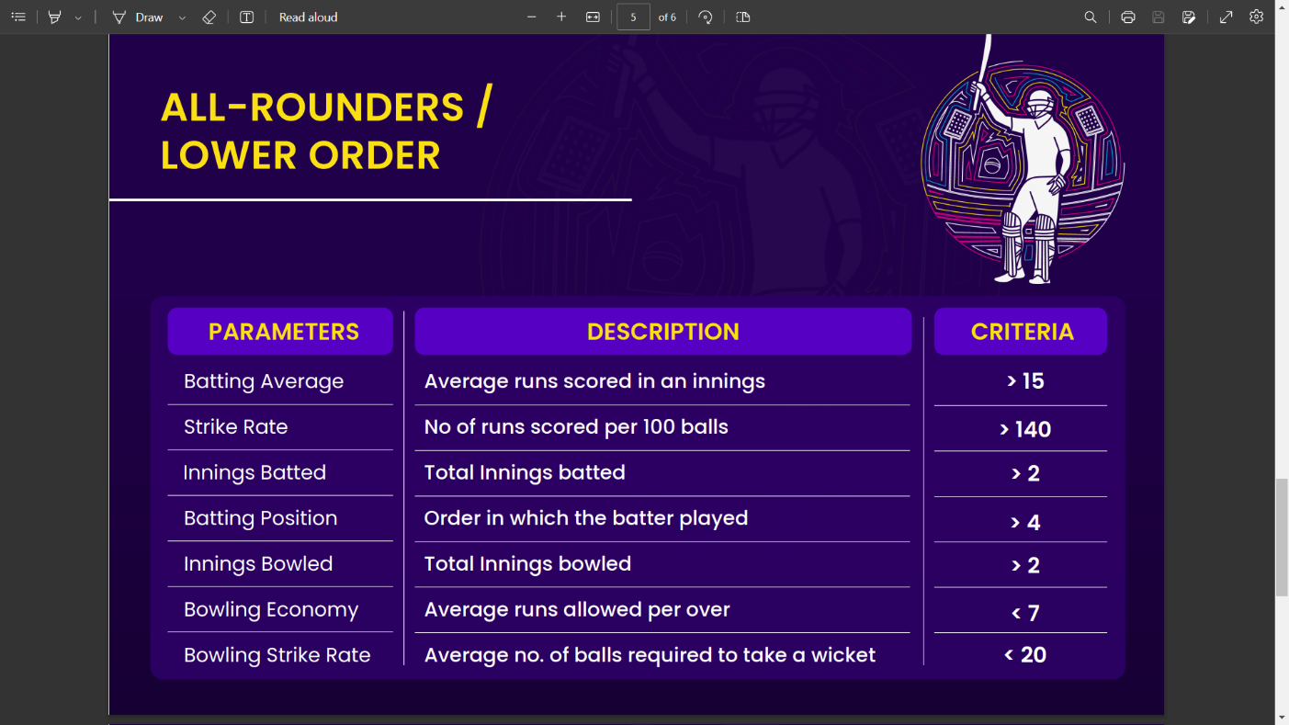

Fig 19.3

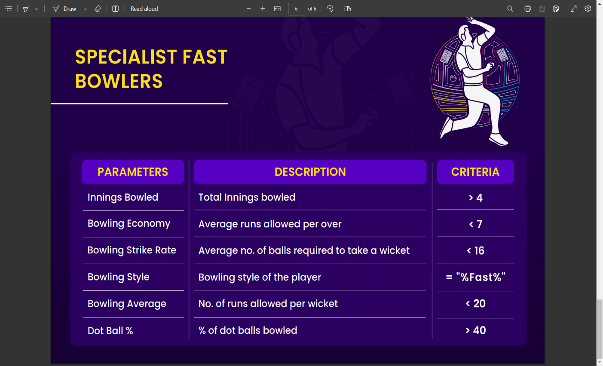

Fig 19.4

After considering all the above criteria, we created a final 11 dashboards which is based on the mentioned layout.

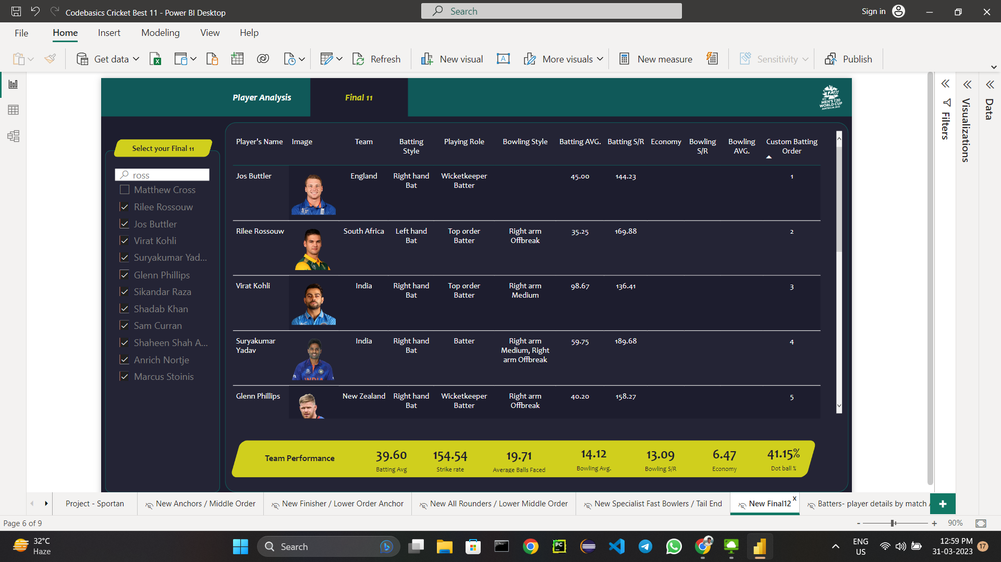

Fig. 20

VI. Future Scope
There are some future works that can be done in order to improve this project.
- The data set can include some of the external factors like player injury, player fatigue, winning streak with a particular team, overall winning streak, average run scored by a team against a particular team in previous matches etc. and on the basis of these data we can try to do the prediction and to check to see the accuracy improves.
- The prediction can also be done taking into consideration the performance of the players in the team like the total number of runs scored by a player in the tournament, the form guide of the player, the number of men of the match awards earned etc. rather than only using a high-level data about the different matches like toss winner, toss decision, home team etc.
- There is no web/mobile applications or UI that my project contains. So, a web/mobile application can be made which would take in the entire data set as input and display the analysis result.
- For now, we have not considered pitch condition, toss winner, weather condition, ground dimensions which may have an impact on result.

Conclusion
This work is basically a data analysis and data visualization implementation in Power BI. The main goal of this analysis is to analyze the data scraped from the portal and creating the strongest XI which can satisfy all the above-mentioned measures and conditions.

Here we have used DAX measures in Power Query to filter according to the criteria. The implementation tools used are Jupyter Notebook, Web scraping portal, Power BI desktop. Hence using this analysis, the best team can be formed.

References
- https://powerbi.microsoft.com
- https://www.packtpub.com/product/microsoft-power-bi-complete-reference
- https://www.oreilly.com/library/view/microsoft-power-bi
- https://github.com
- https://brightdata.com/products/web-scraper
- https://codebasics.io
- https://www.talend.com/resources/data-transformation
- https://www.geeksforgeeks.org/data-transformation
- https://www.edureka.co/blog/introduction-to-power-query
- https://k21academy.com/microsoft-azure/data-analyst/power-query

